DAYS TAKEN FOR WORK
Pearson Edexcel - Tuesday 11 June 2019 - Paper 3 (Calculator) Higher Tier
1.
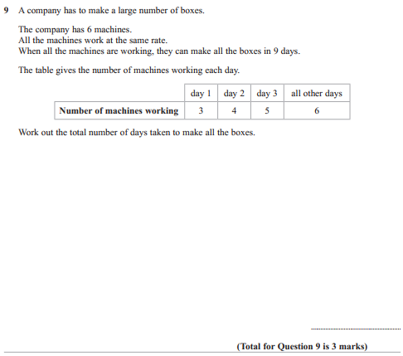

OCR GSCE – Sample Papers – Paper 5 (Non - Calculator) Higher Tier
2.
